Terms of Reference – Community Governance Review of Headington
Introduction
Oxford City Council is carrying out a community governance review in the Headington area in accordance with Part 4, Chapter 3 of the Local Government and Public Involvement in Health Act 2007.
The Council is required to have regard for the guidance on community governance reviews issued by the Secretary of State for Housing, Communities and Local Government. This guidance has been considered in drawing up these terms of reference.
Why are we carrying out a Community Governance Review in Headington
The Council has received a valid request asking for the formation of a community council for the area in Headington covered by the neighbourhood planning referendum undertaken in May 2017.
What is a Community Governance Review?
The community governance review is the process used to consider whether a community council should be created. The request styles the proposed new council as “community”, this type of council is often known as “parish”.
There are two outcomes of the review, depending on the results of the consultation. The review could recommend to Council that:
- there should be no change to the existing arrangements;

- a community council be created;
Who carries out the Review?
The City Council is responsible for conducting the review. A decision on whether or not to create a new community council will be taken by city councillors at a meeting of Council in September 2019.
A cross-party member working group will be created to consider the responses to the review, along with officers, to inform the final report to Council later in 2019.
What area is being reviewed?
The area under review is the Headington area covered by the neighbourhood planning referendum in 2017. This is made up of the whole of Headington ward and parts of Barton & Sandhills, Quarry & Risinghurst, Churchill and Headington Hill & Northway wards.
An indicative map of the area covered is below:
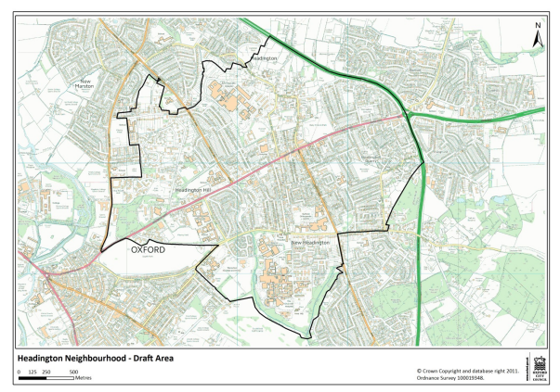
As part of the review the Council has to provide the number of electors in the area. If the Council recommends that a community council should be set up, this information will be used to decide on the electoral arrangements, e.g. how many councillors on the community council.
The Council has used the register of electors of 1 January 2019 in providing the electorate figures which are:
City ward | Current electors | Estimated electors in 2023
Headington | 4223 | 4545
Headington Hill & Northway (part) | 739 | 1158
Barton & Sandhills (part) | 955 | 970
Churchill (part) | 2174 | 2354
Quarry & Risinghurst (part) | 2615 | 2711
TOTALS | 10708 | 11738

The 2023 estimates take into account proposed developments in the area covered by the CGR.

Who will we consult?
A full consultation process will form part of the Review to take full account of the views of local people. The Act requires the Council to consult the local government electors for the area under review and any other person or body who appears to have an interest in the review and to take the representations that are received into account.
The Council will also identify any other person or body who it feels may have an interest in the review and write to them inviting them to submit their views at both stages of consultation.
This will include but are not restricted to:
- city councillors
- tenants and residents’ associations
- groups and societies
- schools and colleges
- Member of Parliament
- Oxfordshire Association of Local Councils
- local political parties
- the County Council and county councillors for the area
The Council will also be pleased to receive comments from any other person or body that wishes to make representations.
As required by Section 79(3) of the Local Government and Public Involvement in Health Act 2007, the Council will notify Oxfordshire County Council that a review is to be undertaken, provide it with a copy of the terms of reference for the review and will consult it on the matters under review.
The Council intends to clearly publish all decisions taken and the reasons for taking those decisions and will work towards the Government’s view that “Community Governance Reviews should be conducted transparently so that local people and other stakeholders who may have an interest are made aware of the outcome of the decisions taken on them and the reasons behind these decisions.”
What matters will the review focus on?
The recommendations made in a community governance review have two main objectives:
- to improve community engagement and better local democracy; and
- more effective and convenient delivery of local services.
The review must ensure that community governance within the area under review reflects the identities and interests of the community in that area and is effective and convenient. It must also take into account any existing arrangements such as community or residents’ associations.
Timetable for the Review
Publication of these Terms of Reference formally begins the review, and the review must be completed within twelve months.
Stage | Timing | Function
Stage One | 13 February 2019 | Agreement by Council to the terms of reference
Stage Two | February 2019 | Drawing up the pamphlet
Stage Three | April-June 2019 | Distribution of pamphlet and a eight-week period for replies
Stage Four | July-August 2019 | Reviewing replies and preparing to report to Council
Stage Five | 7 October 2019 | Report to Council on consultation results
Stage Six | April 2020 | (if approved) Creation of community council
Stage Seven | May 2020 | (if approved) First elections to the new council
How to submit your views
You can submit your views by:
Going to: *tbc*
Writing to:
Community Governance Review (Electoral Services)
Oxford City Council
Town Hall
St. Aldate’s
Oxford
OX1 1BX
Emailing: headingtonCGR@oxford.gov.uk
When will the review begin?
The review will begin in April 2019.

